**Department Of Economics BOS Meetings Minutes**

Meeting Date 11/10/19

Today on 11/10/19 the meeting of the Board of study (Economics) for determining the syllabus for the session 2019-2020 of Postgraduate classes (M.A. Economics) in the department of economics is held in the presence of the following members

1. Dr. J.N. Panday, Head of department Chairman 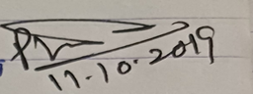
2. Smt. Rajani Sarathi member 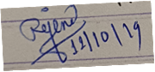
3. Dr. Vijay Kumar Sharma ,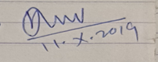

Professor – Government New girls collage, Bilaspur (Chhattisgarh)

1. Dr. Amarkant Panday, professor, Member,

University Education Department,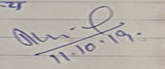

Pt. Ravishankar University, Raipur(Ch.10)

1. Dr. K. Padmavati,- member Assistant Professor

Graduate Collage Durg (C.G.)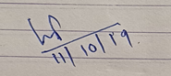

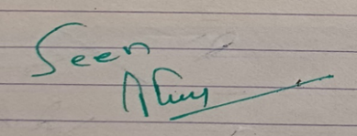

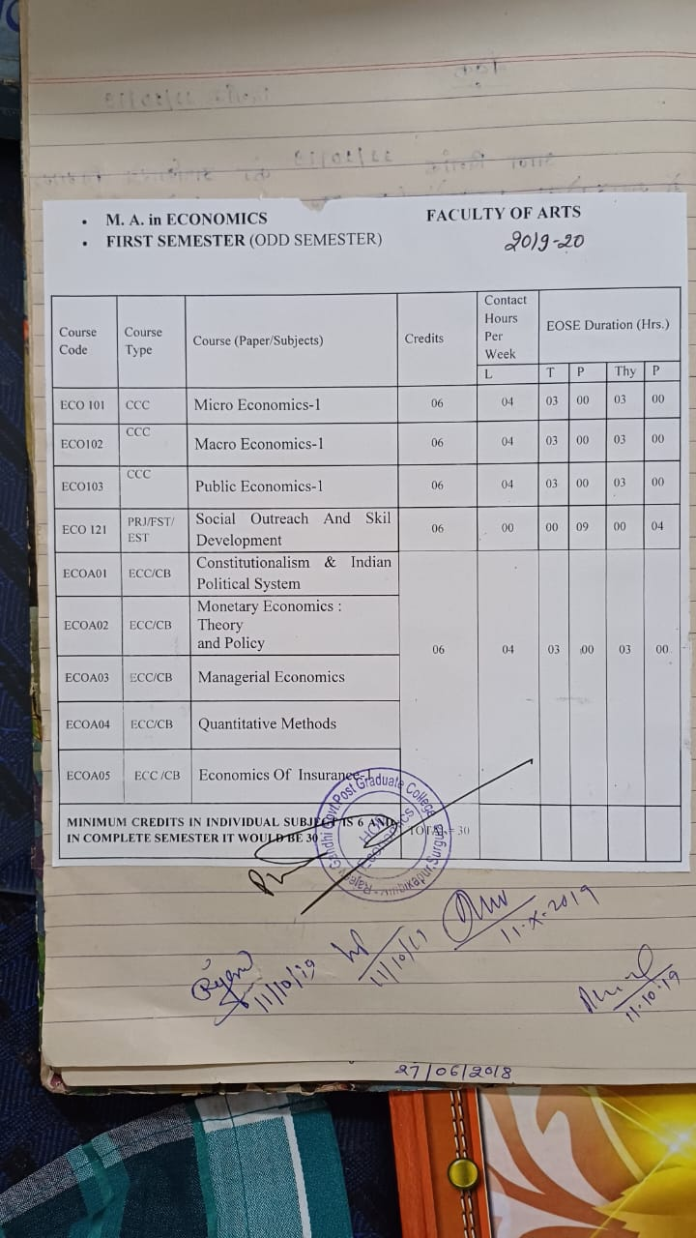

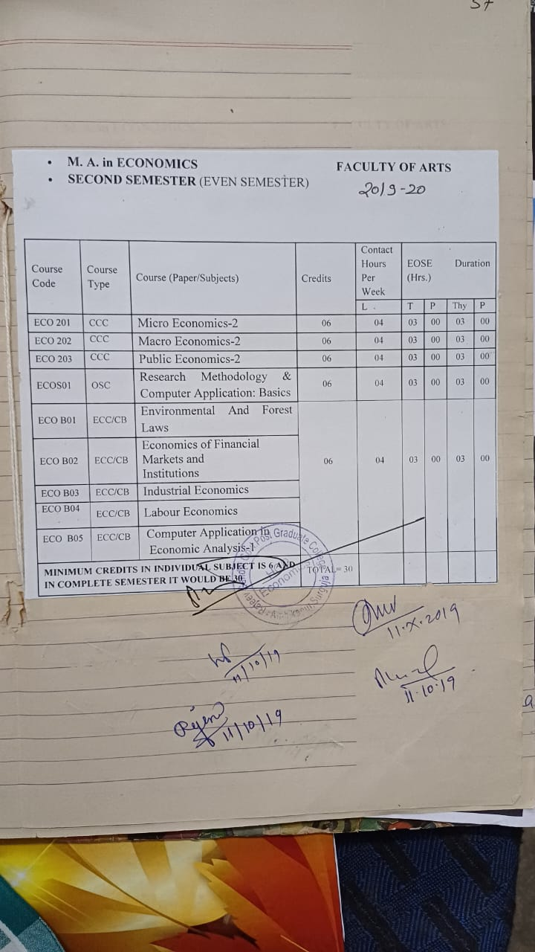

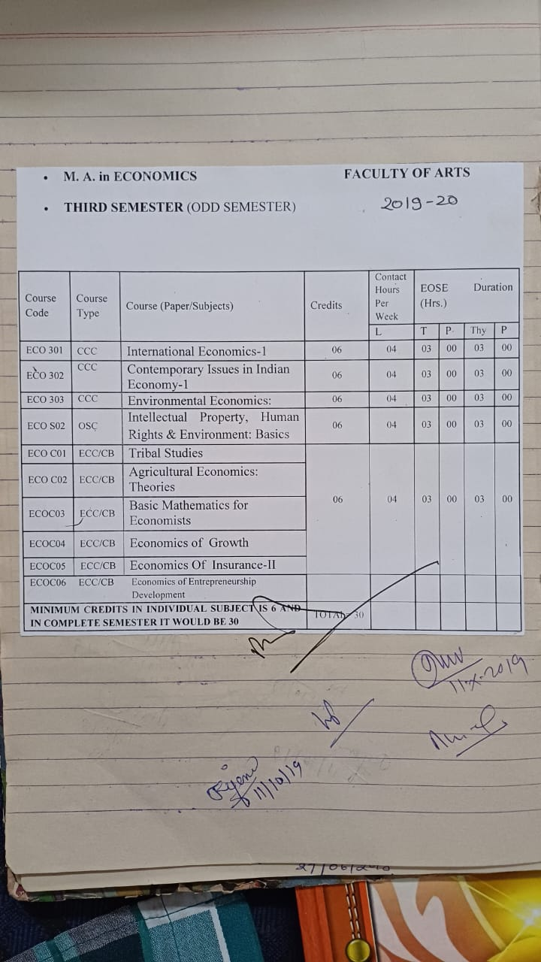

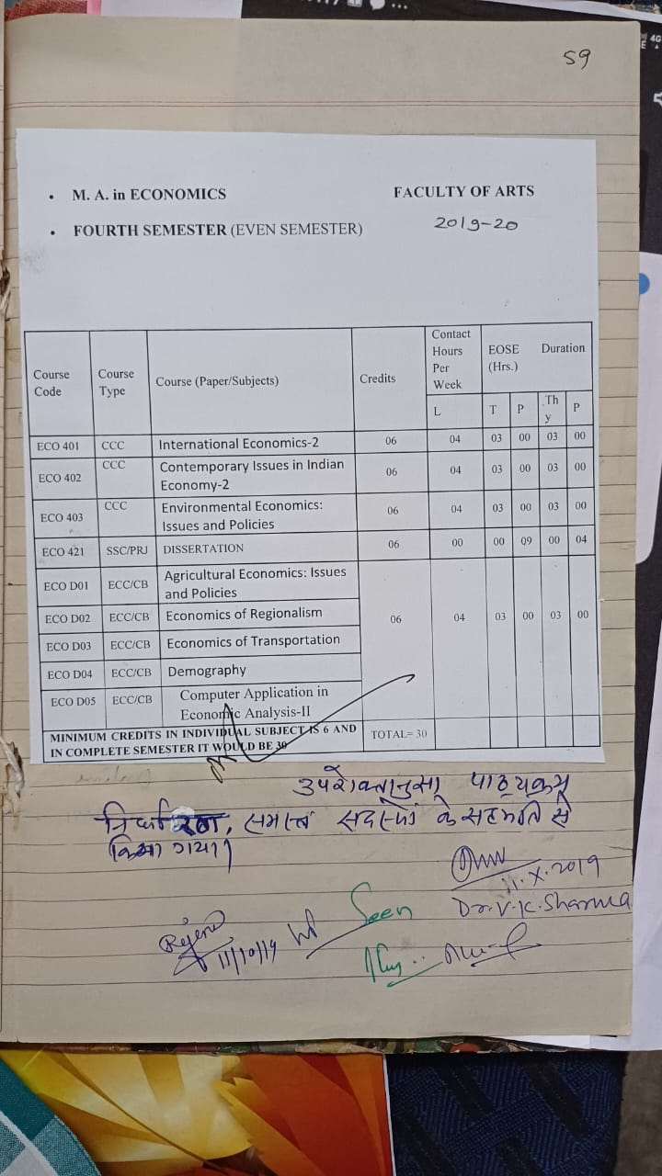

The curriculum as above was determined with the consent of the member. 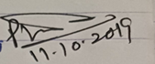

 

 

**BOS Meeting**

**Department Of Economics BOS Meetings Minutes**

Session meeting 2020-21 Date 22/01/2021

Today on 22/01/2021 the meeting of the study board (Economics) for determining the syllabus for the session 2020-2021 of postgraduate classes (M.A. Economics) in the department of economics is held in the presence of the following members

The meeting took place on online mode :-

1. Dr . J.N.Pandey **Head of Department Economics** 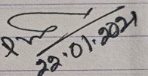
2. Smt. Rajani Sarathi – member 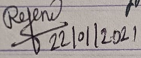
3. Dr. Vijay Kumar Sharma professor  **-online**

Govt. girls collage Bilaspur (C.G.)

1. Dr. Amarkant Pandey professor – member **- online**

University education department pt. Ravishankar Shukla Raipur

1. Dr. K. Padmavati – member - **online**

assistant professor Govt. V.Y.T. PG College Durg (C.G.)

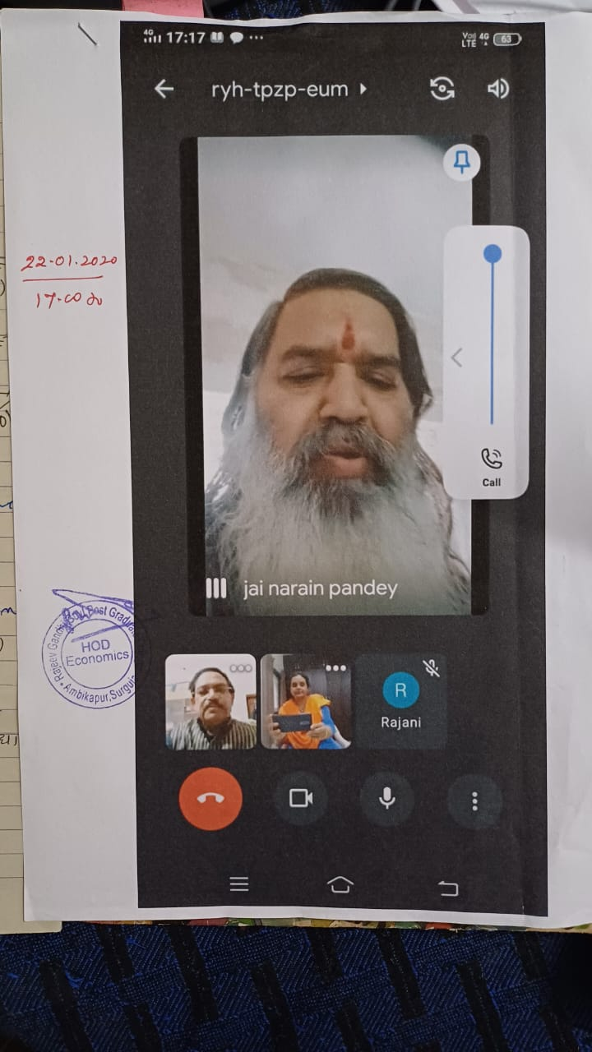

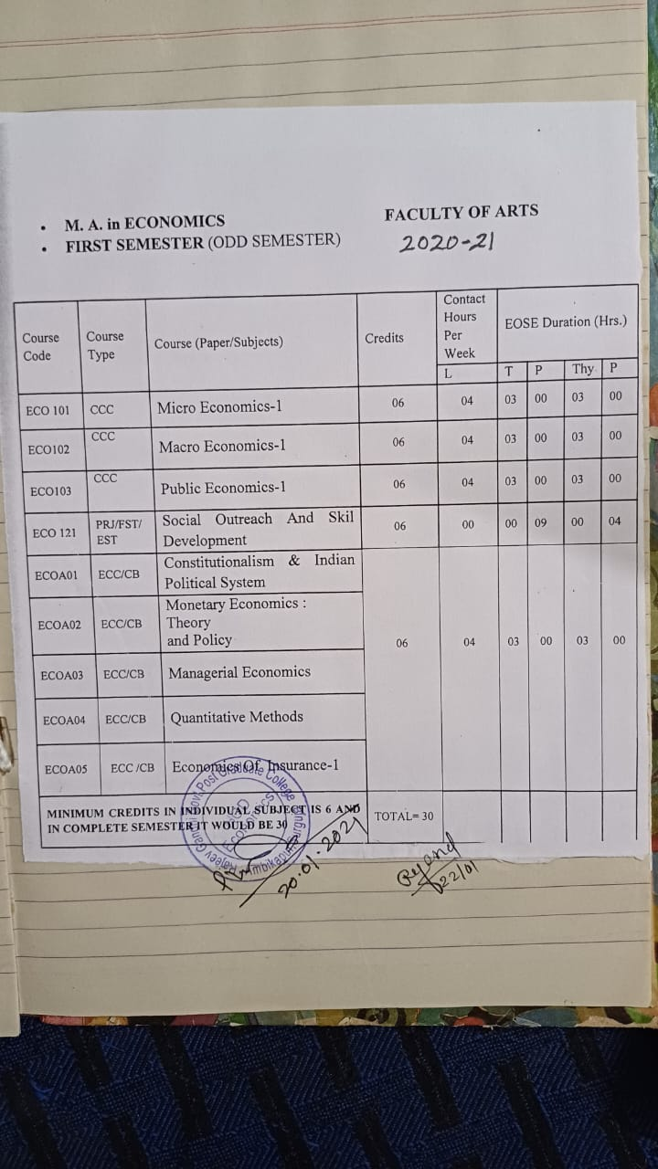

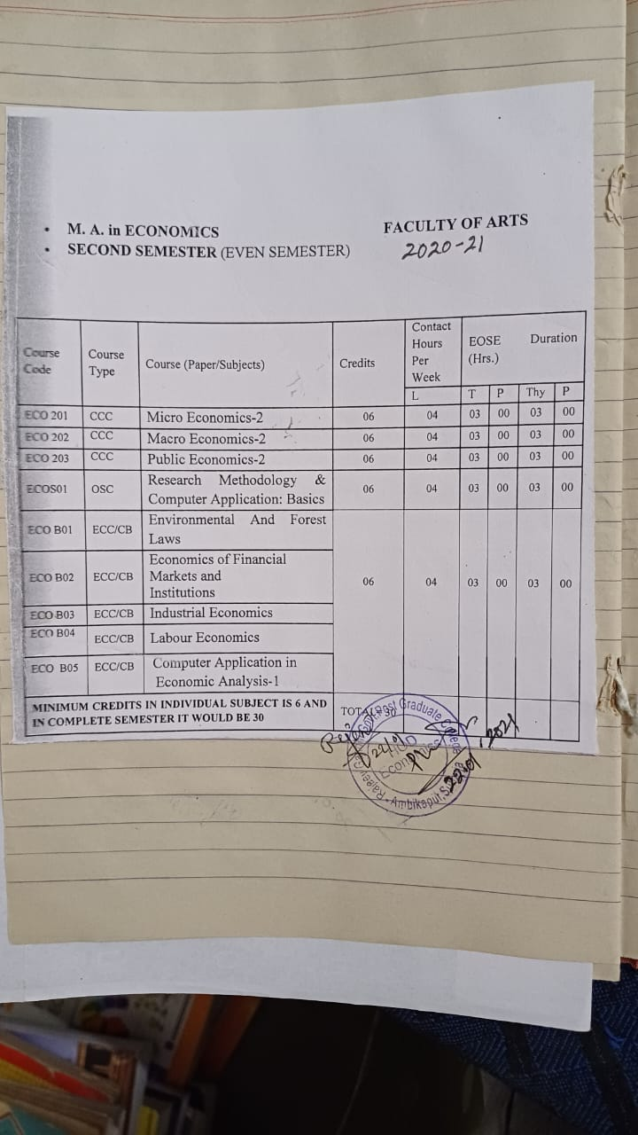

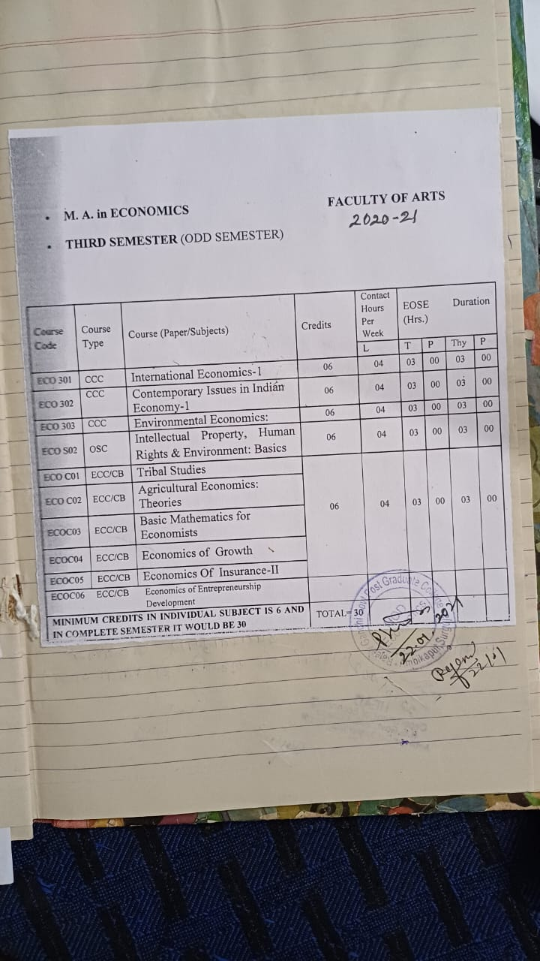

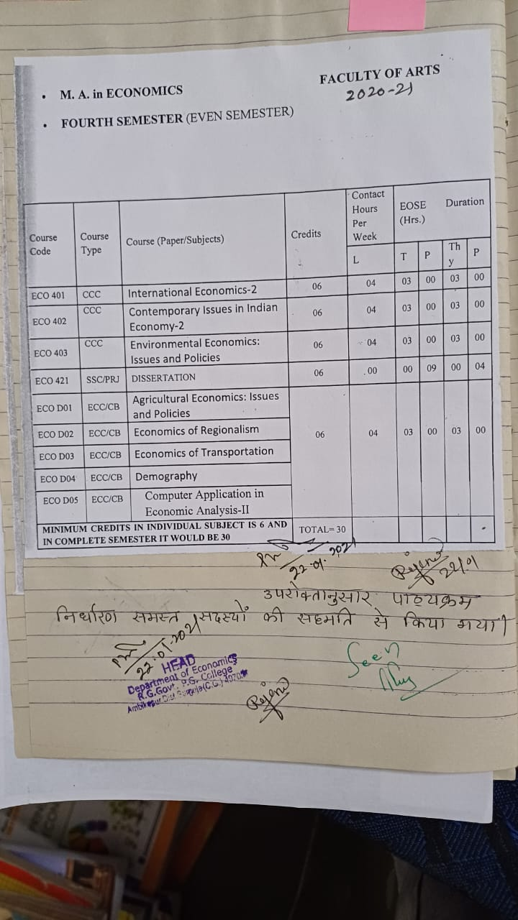

The curriculum as above is determined with the consent of the member.

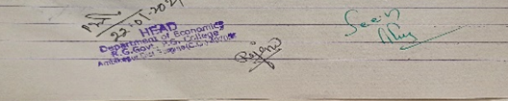

**BOS Meeting**

**Department Of Economics BOS Meetings Minutes**

Session – 2021-22 Date 23/07/21

Today on 23/07/21 the meeting of the Board of Study (Economics) for determining the syllabus for the session 2021-2022 of postgraduate classes (M.A. Economics) in the department of economics was held in the presence of the following members

The meeting took place on online mode :-

1.Dr . J.N. Pandey **Head of Department Economics** 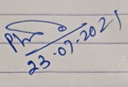

2.Smt. Rajani Sarathi – member 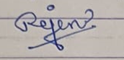

3.Dr. Vijay Kumar Sharma professor -Govt. girls collage Bilaspur (C.G.) - **online**

4.Dr. Amarkant Pandey professor – member-University education department pt. Ravishankar Shukla Raipur **-online**

5.Dr. K. Padmavati – member - online assistant professor Govt. V.Y.T. PG College Durg (C.G.) – **online**

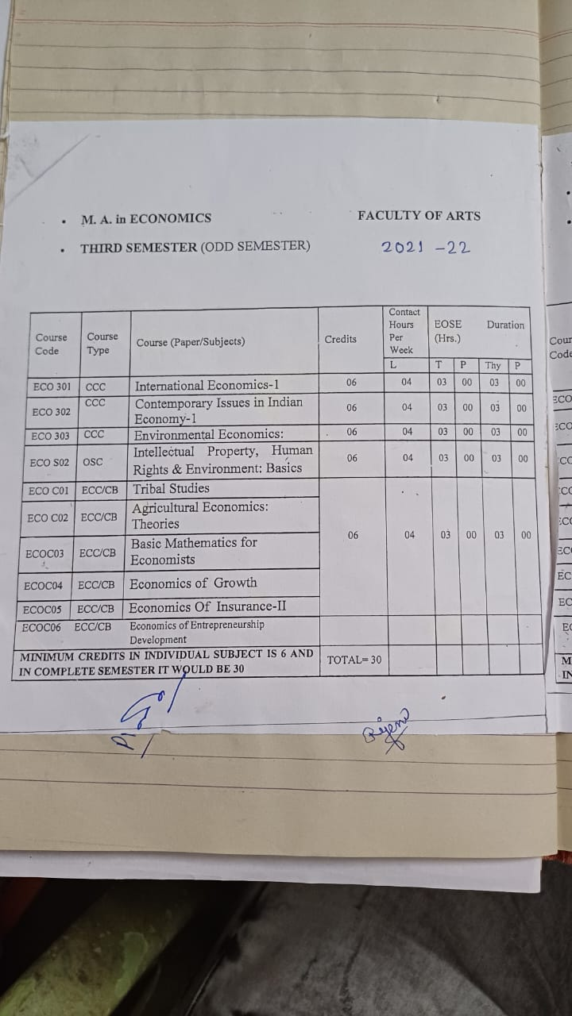

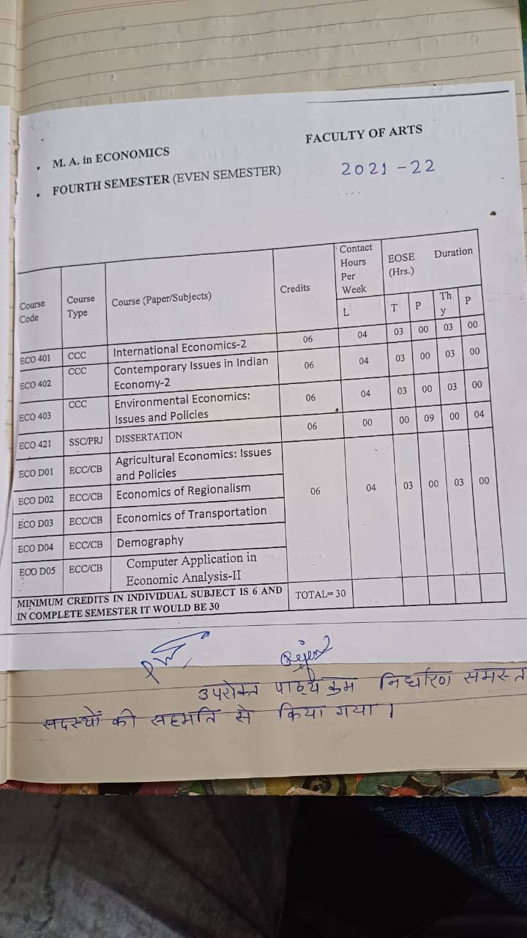

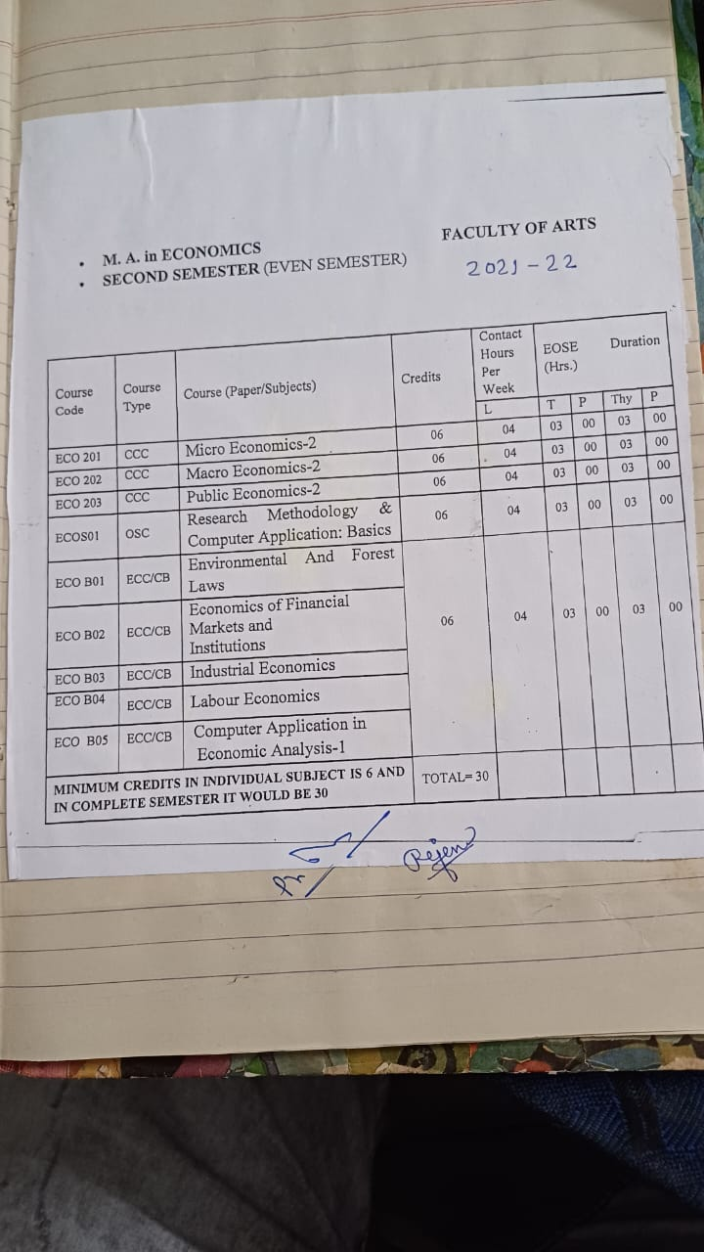

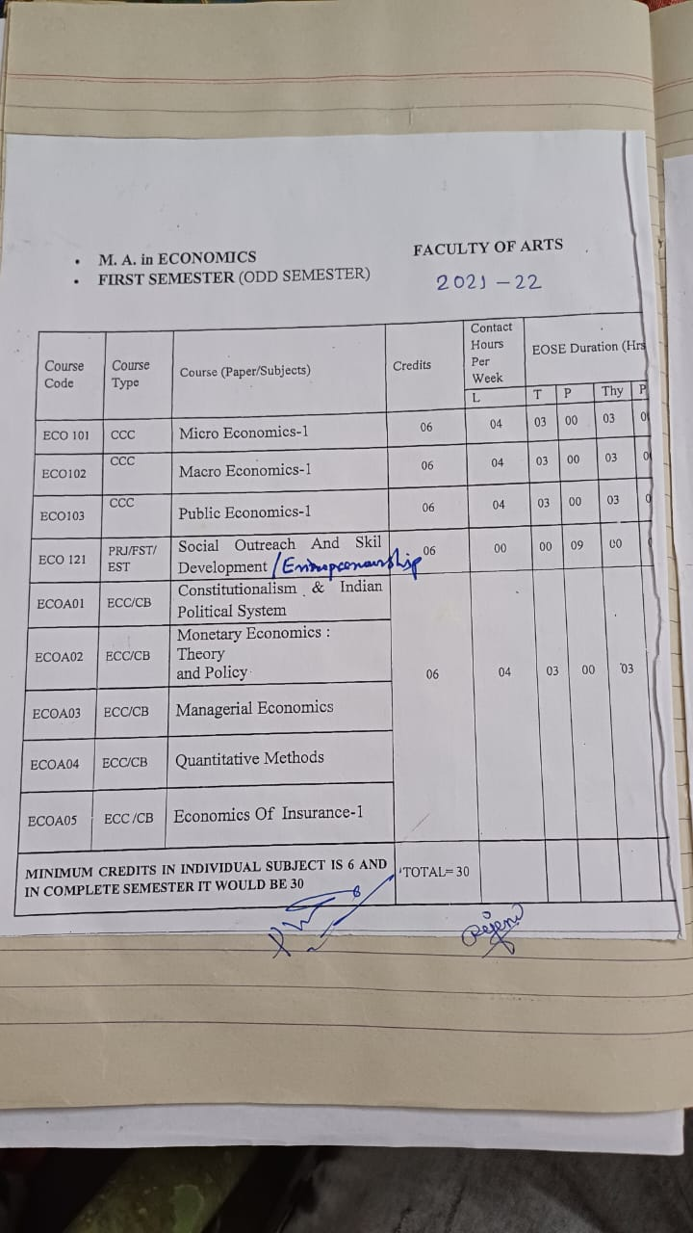

Papers, each of the above courses in the sequence include the outcome of the base of questions education programme outcome and course outcome with mapping question and decision of course content the session 2020-21 has been kept unchanged on.

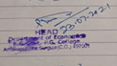 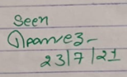



**BOS Meeting**

**Department Of Economics BOS Meetings Minutes**

Session 2022-23 Date 15/07/22

Today on the meeting of the board of study Economies Is held under the chairmanship of Department- Head Dr. J.N. Pandey in the following members are present.

1. Dr. J.N. Pandey – chairman
2. Dr.V.K. Sharma Member (online)
3. Dr. Mrs. K. Pamavati – Member
4. Smt. Rajani Sarathi -Member
5. Ms. Anisa lakra – Member

In the meeting of the curriculam the syllybus was decided as follows

1. In the session syllabus of M.A. postgraduation economics Gandhi Dr.J.K.Mehta has beenn added in the Gro Economics of gramin paper of the third semester of 2022-23. The rest of the article has been kept as it is. (Same as session 2021-22)
2. Indian Economics of Post Graduate Economics

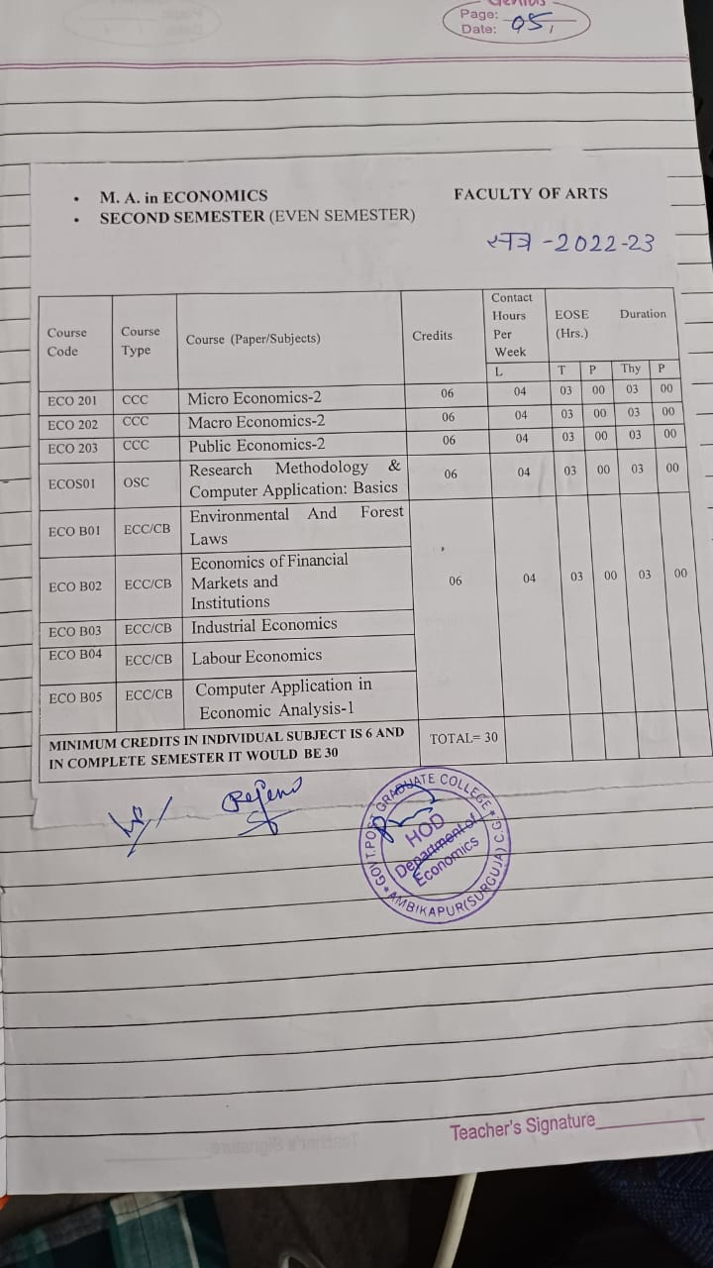

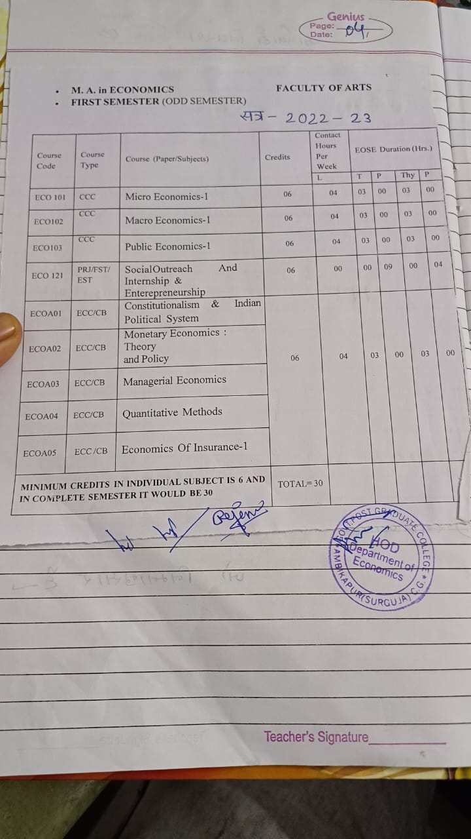

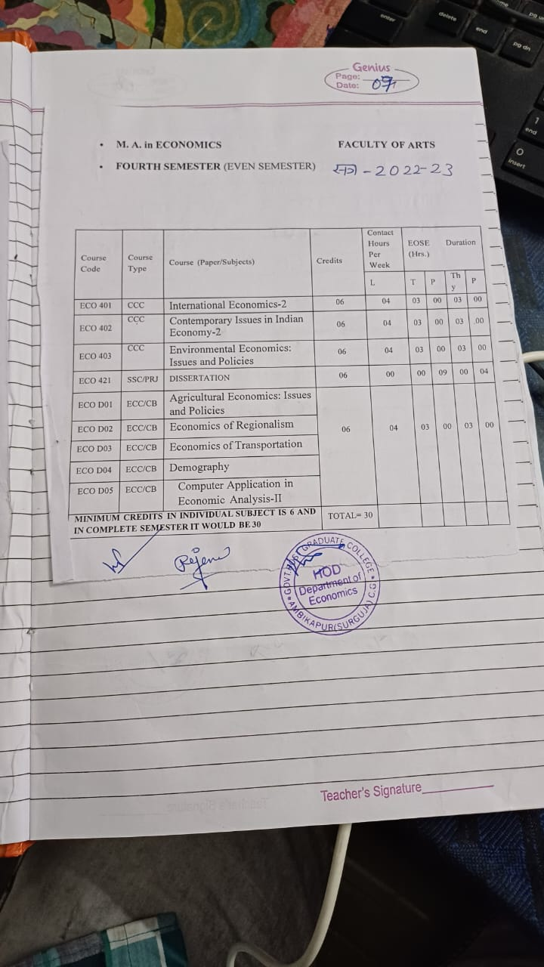

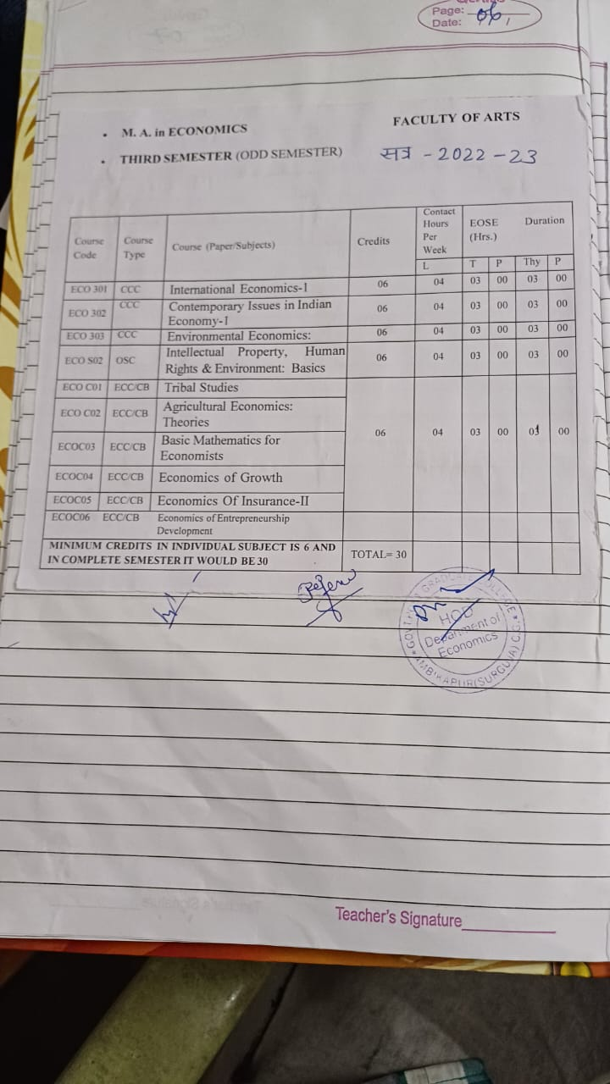

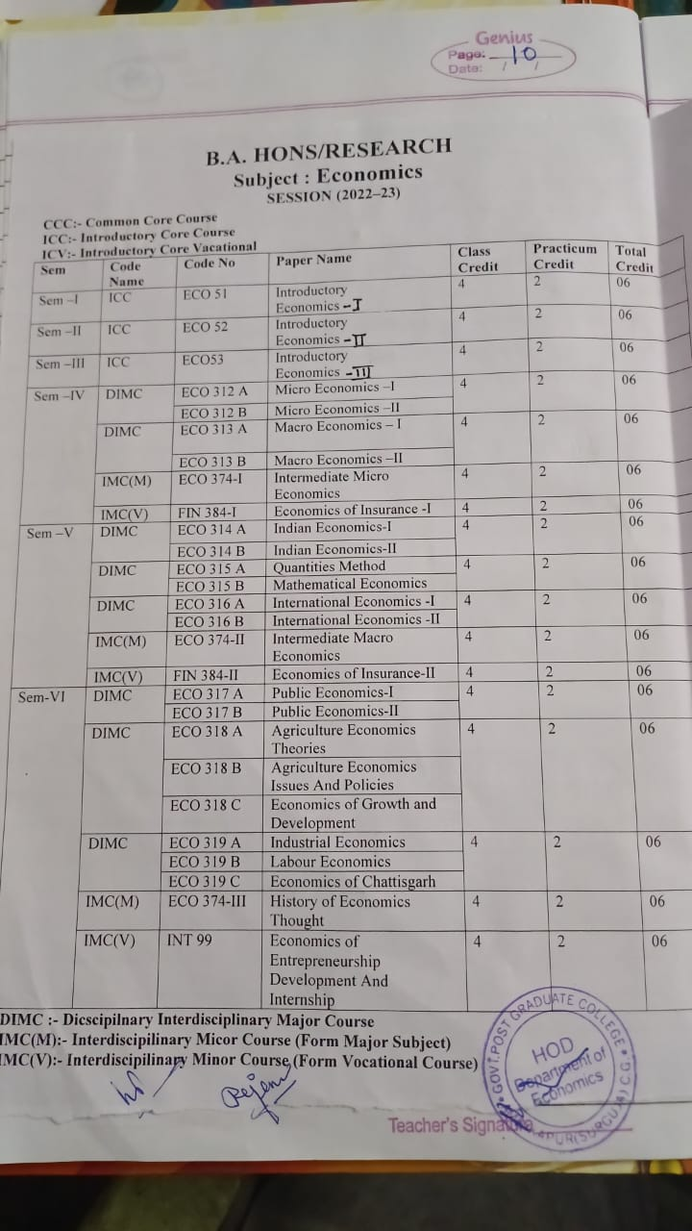

Graduat As postgraduate/Graduate above the postgraduate B.A. Houoners member courses were decided by the after teaching medal decision take by the honourable Smt. Rajani Sarathi expressed the opinion to all the honourable members, the meeting was adjourned and the meeting was conducted accordingly.

1.Dr . J.N. Pandey Head of Department Economics

2.Smt. Rajani Sarathi – member

3.Dr. Vijay Kumar Sharma professor -Govt. girls collage Bilaspur (C.G.) - online

4.Dr. Amarkant Pandey professor – member-University education department pt. Ravishankar Shukla Raipur -online

5.Dr. K. Padmavati – member - online assistant professor Govt. V.Y.T. PG College Durg (C.G.) – online

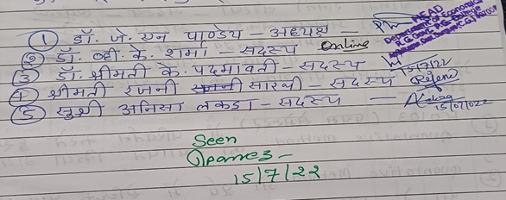 session 2023-23

**BOS Meeting**

**Department Of Economics BOS Meetings Minutes**

Session meeting 2023**-**24Date 12/08/2023

Today on the meeting of the board of study Economies is held under the chairman of Department- Head Dr. J.N. Pandey in the following members are present

1.Dr. J.N. Pandey – chairman

2.Dr. Mrs. K. Padmavati – Member

3.Smt. Rajani Sarathi -Member

4.Ms. Anisa lakra – Member

5. Ashok Kumar – alumni course

Determined as follows the syllabus has been semester

1. Quantitative methods change as ECOA04

FCO13 (1ST Semester)

1. Quantitative methods as ECOQA04

In a place of formerly options paper

* The syllaybus of History of Economics

Thought was deremined.

Remaining question papers have been kept as before the first semester.

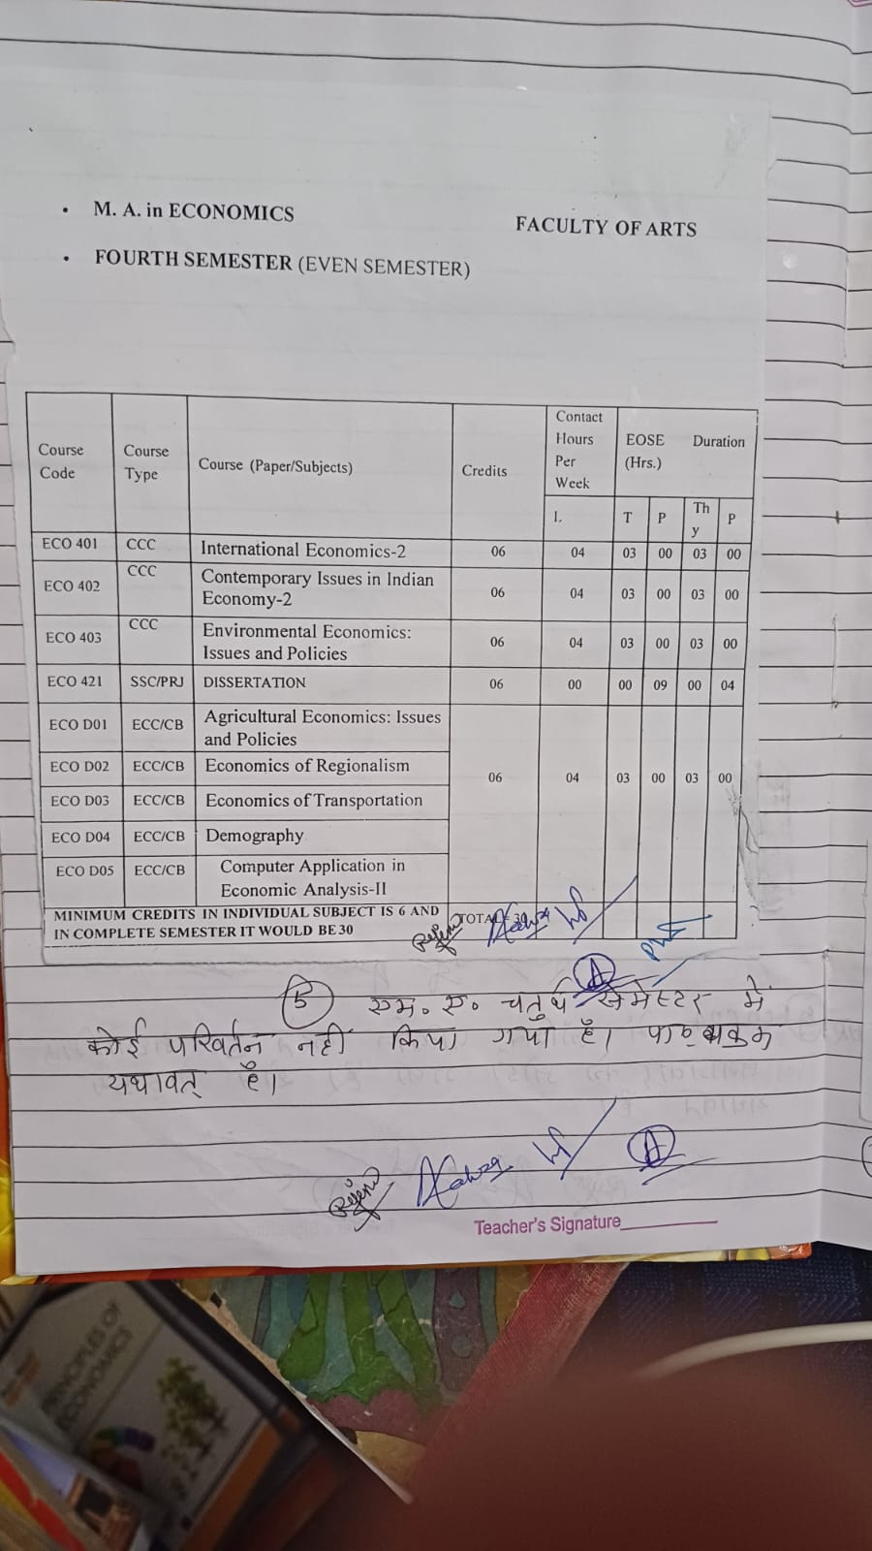

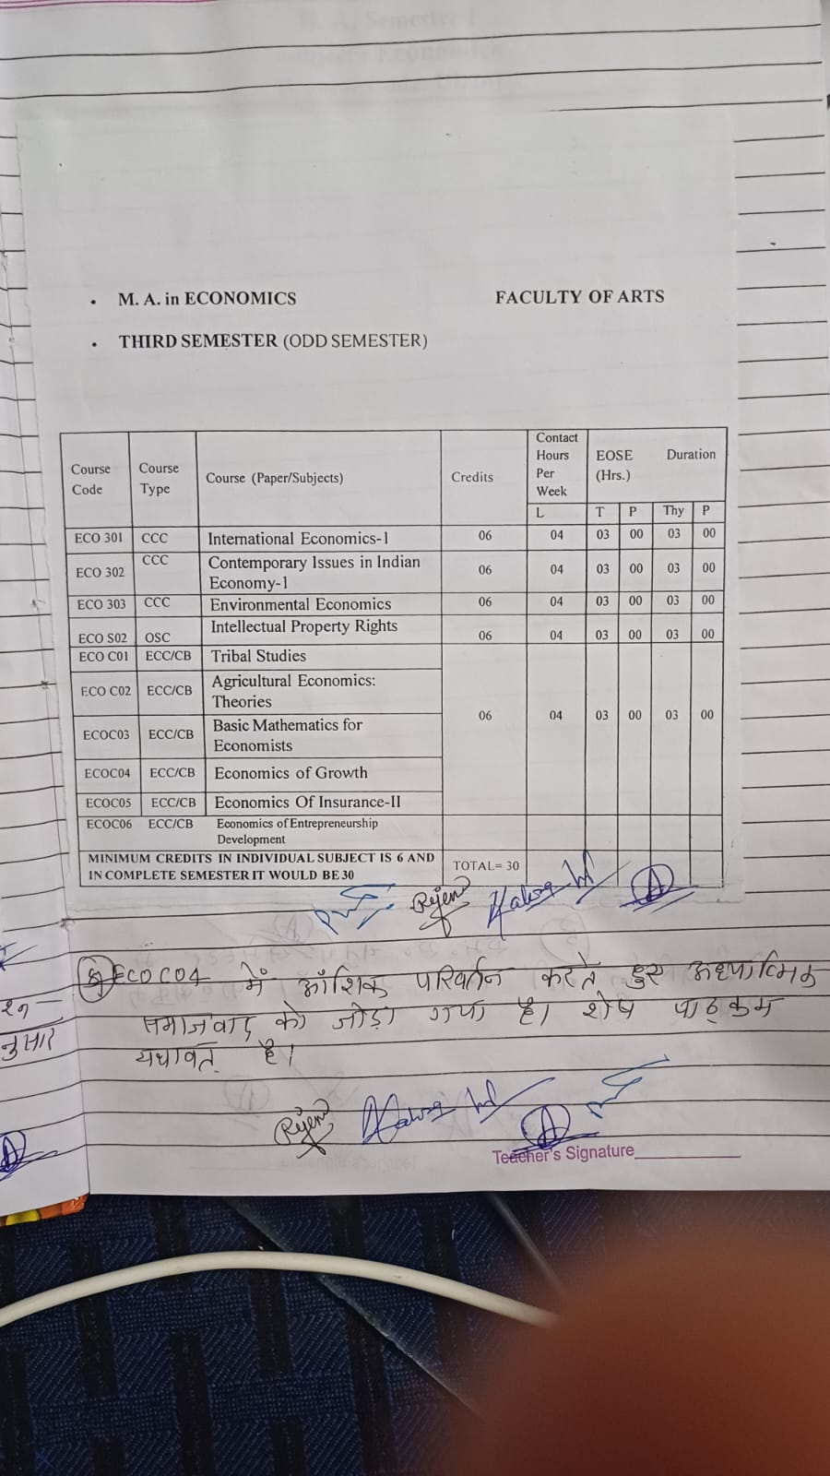

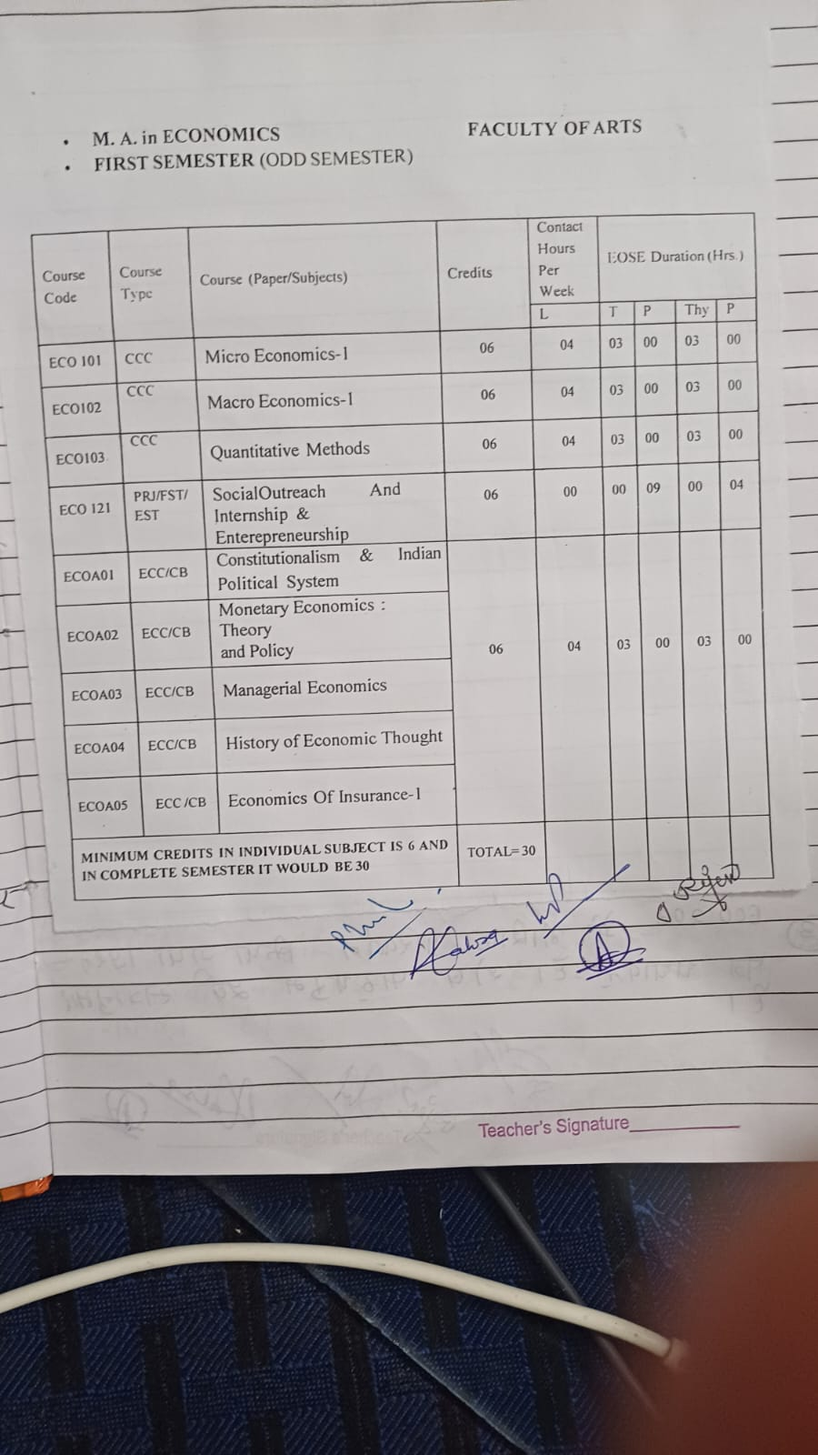

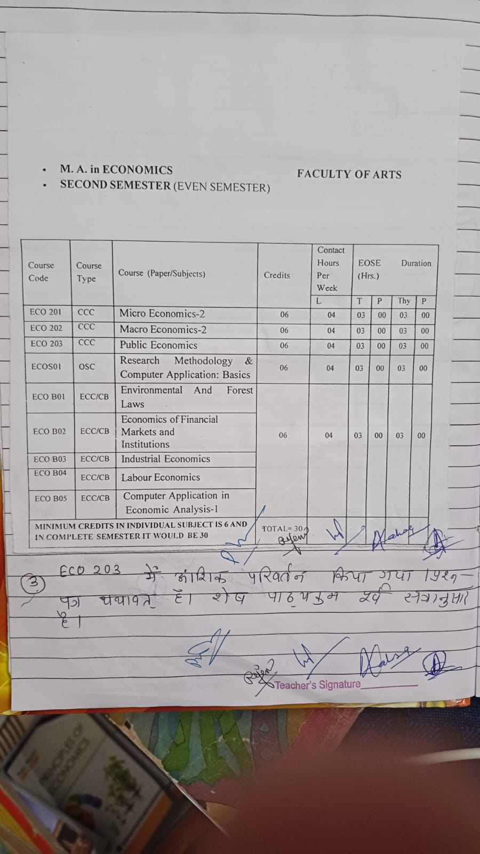

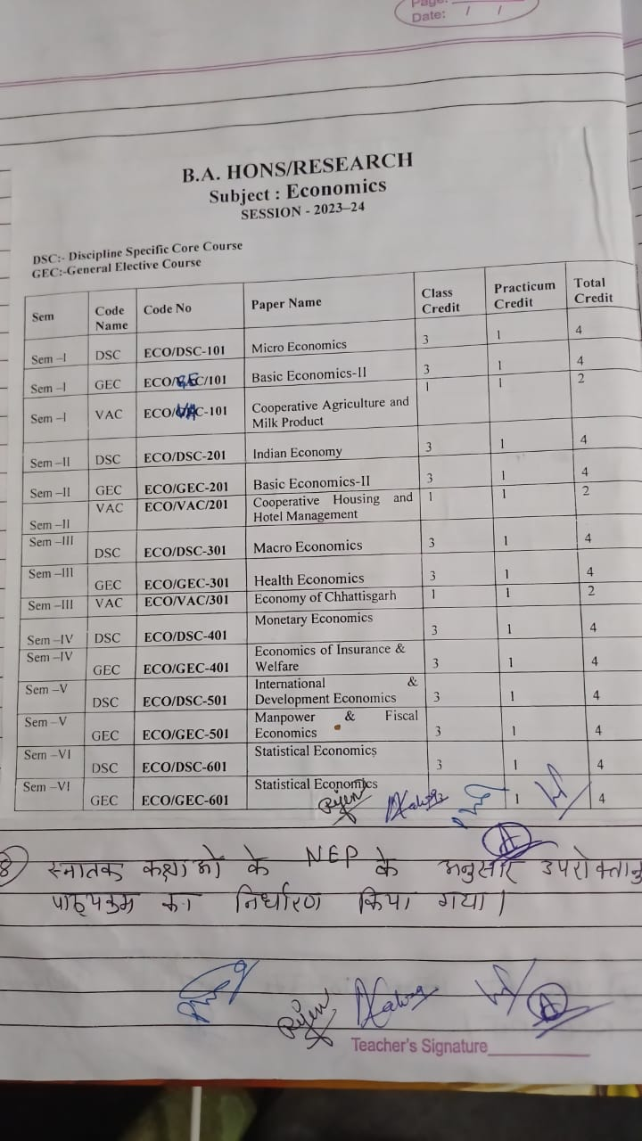

Mrs. Rajani Sarathi expressed her gratitude amd announced the adjournment of the meetings of the Bank/Depertment Head.

1.Dr. J.N. Pandey – **chairman** 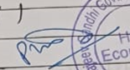

2.Dr. Mrs. K. Pamavati – Member 

3.Smt. Rajani Sarathi -Member 

4.Ms. Anisa lakra – Member

5. Ashok Kumar – Ex. student 